**MAKERERE UNIVERSITY**

**SCHOOL OF COMPUTING AND INFORMATICS TECHNOLOGY**

**SEMESTER II 2022/2023 TEST ONE**

**PROGRAMME:** BIST YEAR II

**COURSE NAME:** IST PROJECT MANAGEMENT **COURSE NAME:** IST 2204

**INSTTRUCTIONS:** ATTEMPT ALL QUESTIONS TIME: **1HR**

**QUESTION 1**

1. With two examples from IT domain, define is a project? (2 marks)

* **A temporary endeavor undertaken to create a unique product or service.**
  + - ***System merger***
    - ***mobile App system project***
    - ***results mgt sys devt***
    - ***e-learning sys upgrade***
    - ***ERP software development***

1. [Briefly explain three differences between projects and operations](https://projectinsight.com/project-management-basics/projects-and-operations" \l ":~:text=In%20any%20organization%2C%20only%20two,such%20as%20accounting%20or%20production.). (3 marks)

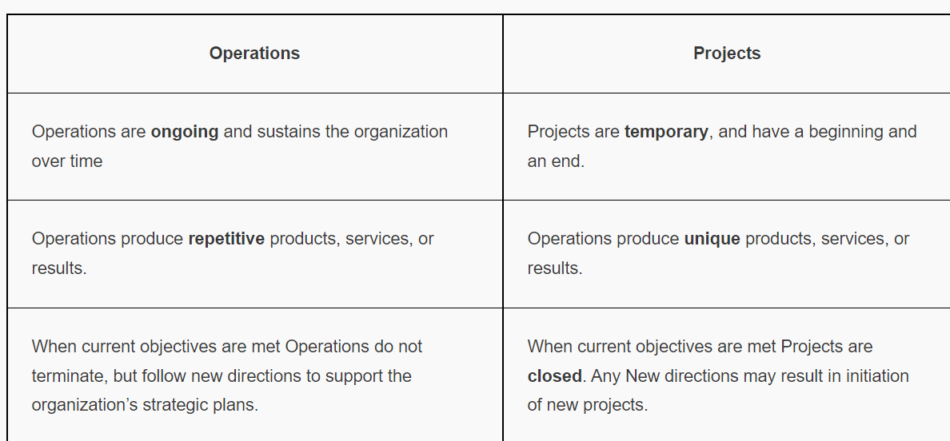

1. Give three suggested skills for all project managers. (3 marks)

* **Communication skills:** listening, persuading
* **Organizational skills:** planning, goal-setting, analyzing
* **Team Building skills:** empathy, motivation Leadership skills: set examples, be energetic, have vision (big picture), delegate, be positive
* **Coping skills:** flexibility, creativity, patience, persistence
* **Technological skills:** experience, project knowledge

1. Effective IS project managers make good use of project management tools and techniques to assist them and their teams in various aspects of project management. Briefly explain any four tools or techniques used by IS project managers. (4 marks)

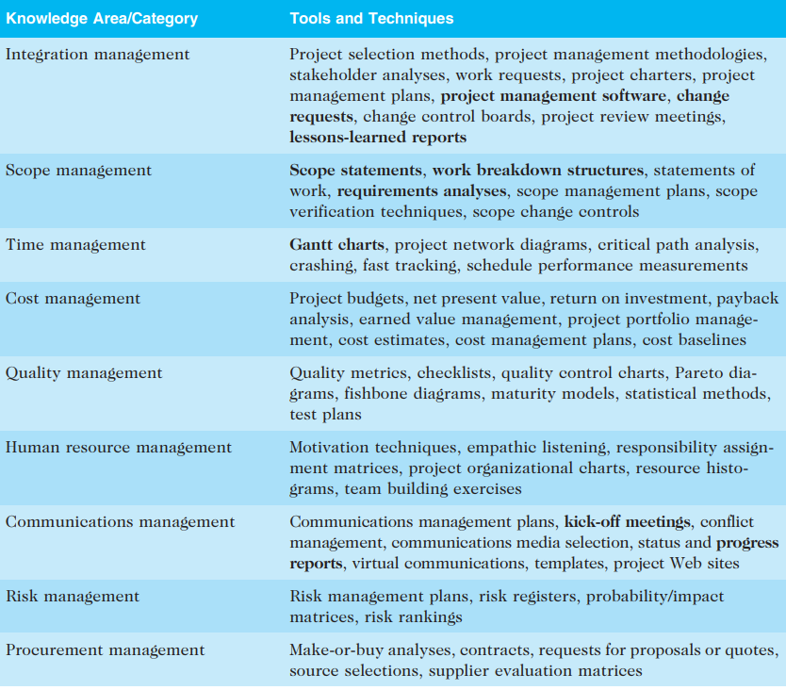

1. Project management can be viewed as a number of interlinked processes groups that produce several project documents. write short notes on four documents produced from the different project processes. (8 marks)

Project Initiation

* + a business case
  + a project charter
  + a stakeholder register

Project Planning

* + A scope statement
  + A work breakdown structure (WBS)
  + A project schedule, in the form of a Gantt chart with all dependencies and resources entered
  + A list of prioritized risks
  + (all project planning documents-time mgt plan, cost mgt plan)

Project Executing

* + A milestone report

Project Closing

* + a final report

Project Monitoring and Controlling

* Status and progress report (performance reports) and updates to various plans

**QUESTION 2**

1. Write short notes on the following project management concepts. (2 marks @)
   1. Requirements traceability matrix

**Is a table that lists requirements, their various attributes, and the status of the requirements to ensure that all are addressed.**

* 1. Scope creep

**Adding additional features or functions of a new product, requirements, or work that is not authorized (i.e., beyond the agreed-upon scope).**

* 1. Systems view of project management

**Systems thinking describes this holistic view of carrying out projects. A systems approach is an overall model for thinking about things as systems. Systems are sets of interacting components working within an environment to fulfill some purpose**.

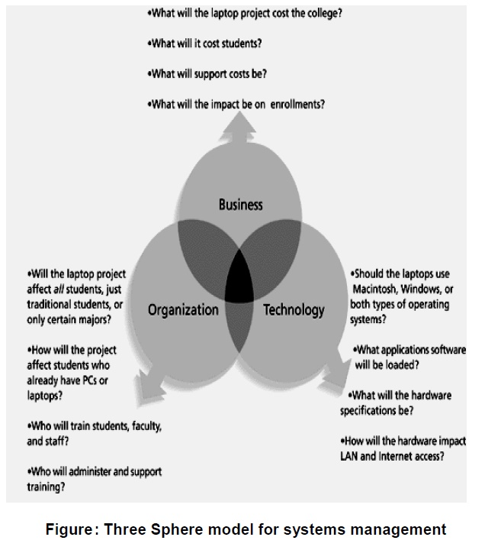

1. With illustrations, briefly explain the differences between the different organizational structures. (6 marks)

**3 basic organizational structures**

* **functional**
* **project**
* **matrix**

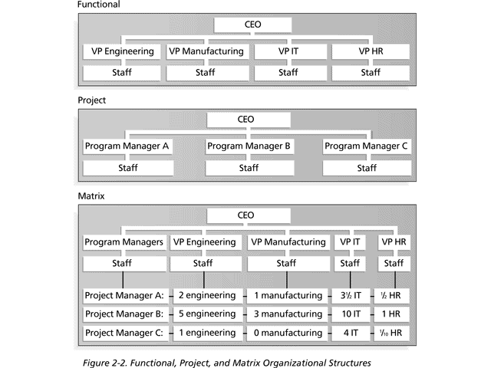

1. A company is considering investing $100,000 in an IST project that is expected to generate cash inflows of $10,000 in year 1, $20,000 in year 2, and $60,000 in year 3. The expected cash outflow is $40,000 for all the years and the discount rate is 20%. Use NPV analysis to determine if the company should invest in the project. (8 marks)

|  |  |  |
| --- | --- | --- |
| 1. **Year** | **Cash flow** | **Present value** |
| YEAR=1 | $(10,000– 40,000) ÷ ( 1 + 0.2)1 | -$ 25,000 |
| YEAR = 2 | ($20,000-$40,000)÷(1+0.2)2 | $13,888.89 |
| YEAR= 3 | ($60,000-$40,000)÷(1+0.2)3 | $ 11,574.07 |
| TOTAL NPV |  | **= $ -27,314.82** |

A negative NPV indicates that the project is not expected to generate sufficient returns to cover the cost of the investment, and as such, the company should not invest in the project. Therefore, based on the NPV analysis, the company should not invest in this IST project.